AM 310 – Instrumentation and Theory of Experiments

Introduction to Oscilloscopes, Multimeters, Power Supplies,
and Function Generators

CONCEPTS: Analog oscilloscopes, Electrical measurements, Digital oscilloscopes, Digital multimeters, Power supplies, Function generators

- Introduction

The objective of this lab is to teach how to use oscilloscopes and multimeters for measuring various electrical quantities. You will also be introduced to additional lab equipment such as function generators and power supplies. This lab provides an introduction to the different methods by which measurements will be made in the remaining AM310 labs.

- Theory

  - Oscilloscopes

Oscilloscopes come in two main varieties: analog and digital. In this introductory lab, an analog one will be used. Analog oscilloscopes are described in detail in the first part of this section; digital oscilloscopes are described briefly in the final paragraph.

The main component of the analog oscilloscope is the cathode-ray tube (CRT). A CRT consists of an electron gun, an evacuated tube (typically made of glass with shape as indicated in Figure 1), and two pairs of metal parallel plates (one oriented in the horizontal direction and the other in the vertical direction) on which voltages can be placed. A fluorescent material is painted onto the inside of the flat portion of the tube. This portion of the tube is more commonly referred to as the ‘screen’ of the oscilloscope.

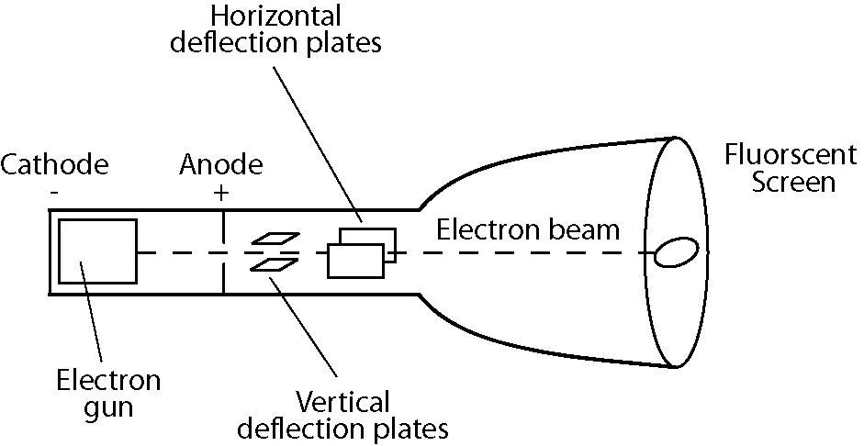

Figure 1: Sketch of cathode-ray tube

The electron gun directs a beam of electrons down the tube towards the screen. Where the electron beam hits the screen, light is emitted due to the interaction of the beam with the fluorescent material. While passing though the tube, the beam is steered by the electric fields due to the voltages on the parallel plates. By placing the correct voltages on the plates, the beam can be directed to any position on the screen. The horizontally oriented plates deflect the beam in the vertical direction, and the vertically oriented plates deflect the beam in the horizontal direction. In Figure 1, the plates are labeled according to their function, not orientation.

Within the oscilloscope a voltage that increases linearly with time is generated. When applied to the vertically-oriented plates, the electron beam is caused to sweep horizontally across the face of the screen leaving a visible trace. If a second varying voltage is applied to the horizontal plates while the electron beam is moving horizontally, the beam will trace a graph of the time dependence of this varying signal. While the first voltage was generated inside the oscilloscope, the second one comes from outside the oscilloscope – it is provided by the measuring transducer being used. It is input to the oscilloscope at a connector on the oscilloscope’s front face. In this fashion, you see on the screen of the scope a continuously updated ‘graph’ of voltage at the input on the vertical axis vs time on the horizontal axis. When the beam reaches the edge of the tube (i.e. the right hand side of the screen as you face it) it is turned off and returned quickly to its starting position (the left hand side of the screen) to continue the trace of the input signal.

One of the most important features of oscilloscopes is their ability to synchronize the start of the beam sweep with a point of constant voltage (and thus a constant phase for periodic signals) from some reference (usually the input signal or other signal phase-locked with the input signal). This feature is known as triggering, and the constant voltage is known as the trigger voltage. Thus, periodic signals look stationary on the oscilloscope screen (except for when viewing very low frequency signals at the largest time per division setting on the horizontal axis; at this setting the sweep speed is slower than your eye).

In contrast to analog oscilloscopes, the signal at the input of a digital oscilloscope does not directly control the deflection voltage on the horizontal plates. Instead the signal is digitized and then this digitized signal is displayed on the screen (a fact which must be kept in mind when interpreting traces displayed on a digital oscilloscope’s screen). A digital oscilloscope can use a CRT, but more commonly they employ LED screens to display the acquired signal. Since digital oscilloscopes digitize the input signal, they have to ability to easily measure different properties of the signal such as RMS voltage (defined in Section 2.2.1), peak voltage, and frequency content. As digital oscilloscopes are used widely in research laboratories you will learn much more about them and use one during the semester.

  - Multimeters

    - Introdution to Multimeters

As their name suggests, multimeters have the ability to measure many different electrical quantities. The quantities that you will measure with a multimeter over the course of the AM 310 labs are: DC voltage, AC RMS (Root-Mean-Squared) voltage, DC current, AC RMS current, and resistance.

Care must be taken when making an RMS measurement with a multimeter as different meters do this differently. The measurement of RMS voltage is discussed below; however all of the ideas presented also apply to RMS measurements of current.

To determine the RMS voltage of a signal, some multimeters actually measure the peak to peak voltage (defined as in Figure 2) and infer what the RMS level is. By assuming that the input signal is periodic at a single frequency the RMS voltage can be calculated from this measurement (you need to derive this expression as part of the pre-lab exercises).

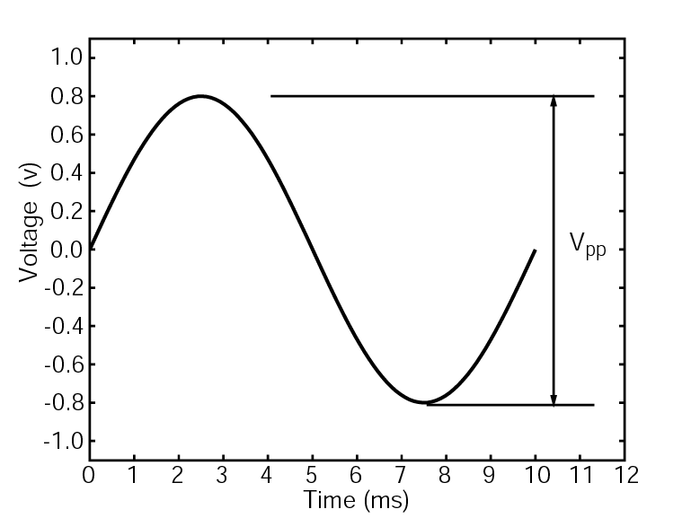

Figure 2: The peak to peak voltage of a signal is the voltage difference between the minimum voltage (at the trough) and the maximum voltage (at the crest). In this case, (a 100 Hz signal), the peak to peak voltage is 1.6 V

Clearly this type of multimeter should only be used when the input signal satisfies these assumptions. Other multimeters measure what is known as ‘true’ RMS voltage. These meters measure the voltage by detecting the amount of heat dissipated by a resistor across which the voltage is placed. Meters of this kind can be used to measure the RMS voltage of any signal, including multi-frequency ones. The RMS value of a signal can also be found by digitally sampling a signal and applying the definition of root-mean-squared for a discrete signal:
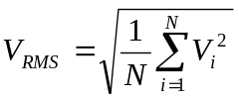 (1)

where N is the number of samples, and i denotes the ith measurement.

    - Making a voltage measurement with a multimeter

If you want to measure the voltage across a component, say for example, a resistor, the multimeter must be put in parallel with the resistor. To make an accurate measurment of the voltage across a component, the input impedance of the multimeter should be much, much greater than the resistance across which the measurement is made. Suppose that the simple circuit in Figure 3 represents a flash light. The DC voltage source on the left is the batteries and the resistor is the flash light bulb. You are interested in knowing the voltage across the bulb. To make this measurement, you must place the leads from the multimeter on either side of the bulb. More specifically, you must place the positive lead between the positive pole of the batteries and the bulb and place the negative lead between the bulb and the negative terminal of the batteries. Placing the probes in this configuration will ensure your measurement to have the correct magnitude and sign.

+
-
Figure 3: To make a voltage measurement of voltage a across a circuit component with a multimeter, the meter must be placed in parallel with the component.

When measuring the RMS voltage of an AC signal with a multimeter, the probes must also be placed so that the meter is in parallel with the component. The orientation of the probes does not matter in this case as RMS voltage is always a positive quantity by definition.

    - Making a current measurement with a multimeter

In contrast to making voltage measurements, for which the multimeter was connected in parallel with the circuit, current measurements require the meter to be placed in series with the circuit. This is diagrammed below in Figure 4.
+
-
Figure 4: To make a measurement of the current drawn by a circuit, the meter must be placed in series with the circuit

Notice in Figure 4 that the portion of the circuit between the two probes has been removed. The idea is to make the current flow through the meter so it can be measured, and then return it to the circuit. For DC current measurements, the placement of the probes must follow the same rules as for DC voltage measurement. For AC current measurements the placement of the probes does not matter.

  - Function Generators

Function generators create time varying voltage signals, typically sine-, triangle-, and square-wave signals that can be generated with a range of amplitudes and frequencies. Today many models include options for arbitrary waveform generation, frequency sweeps, pulses, and other features. A TRIG or SYNC signal is commonly provided to synchronize other instrumentation with the periodic nature of the primary signal or pulse. Function generators are typically designed to for use with equipment having a specified input impedance. If the equipment you are using with your function generator does not have that impedance, you must carefully measure and monitor the actual voltage amplitude delivered to the component you are driving with the function generator. In this case you cannot rely on the voltage amplitude displayed on the function generator’s display – it will not be the same as the voltage delivered to the equipment. Using equipment with input impedance less than the output impedance of a function generator requires the function generator to supply more current to the device than it is capable of, which could damage the function generator.

  - Power Supplies

Many measuring transducers require a bias voltage to operate. The voltage is supplied by a DC power supply either integral to the transducer, or external to it. Usually internal power supplies provide only one voltage. External ones, however, can supply a range of voltages. Common ranges are ±6V, ±15V, and ±21V.

- Introduction to the Equipment Used in AM 310 Labs

This section is intended to introduce the specific equipment that will be used in the AM 310 labs. The equipment is stored on rolling carts; each contains an analog oscilloscope, a multimeter, a function generator, and a power supply. Each cart also contains a computer that can be used for computerized data acquisition. You will not use the computer during this first lab. When performing the labs, be sure to take note of which cart you are using, and also the serial and model numbers of the equipment stored on it. There are copies of the user manuals for each piece of equipment (the oscilloscope, multimeter, function generator, and power supply) available. Should you need to refer to one (i.e. to check the specifications of the equipment to perform uncertainty analyses on the data you collect); the TF can provide you with a copy on loan.

  - Cables, Connectors and Adaptors

To make connections between two components (for example the function generator and the oscilloscope) a BNC cable with or without supplemental adaptors (depending on the two pieces of equipment being connected) will be used. Two different types of supplemental adaptors are shown in Figures 5 and 6. BNC stands for Bayonet Neill-Concelman. Bayonet refers to the type of connector, and Neill and Concelman refer to the two engineers to who developed the connector in the late 1940’s. A cable is called a BNC cable if it has BNC connectors on its ends. The male gender of the BNC connector (Figure 5), called the plug, has a pin in its center to mate with the hole at the center of the female connector (the socket, Figure 6).

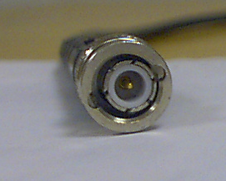

Figure 5: BNC Plug

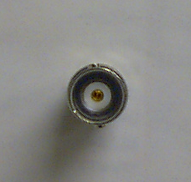

Figure 6: BNC Socket

To provide a tight mechanical coupling between the plug and the socket, the BNC plug has a spring-loaded rotate-able outer collar which contains two helical channels with notches at their ends. During installation, the channels guide the collar over two radially directed pins which stick out from the socket. When properly installed, the two notches at the ends of the helical channels rest on the pins on the socket. The spring in the collar acts so as to keep the BNC plug rigidly mounted to the socket. The coupling system is similar to that used to fix bayonets to guns, hence the classification mentioned above. The outer part of a BNC connector, usually silver in color, is connected to ground. The inner pin is isolated from ground by an insulating material, and carries the signal voltage.

The cable to which the BNC connectors are attached is called a coaxial cable. Coaxial cable is so named because of the arrangement of the signal and ground lines in the cable – they share a common center, therefore they are ‘coaxial.’ A cross section diagram of a coaxial cable is shown in Figure 7.

Outer Insulator
Ground Sheath
Inner Insulator
Signal lead

Figure 7: Cross section diagram of Coaxial Cable

From outside in, a coaxial cable consists of an outer insulator, a ground sheath, a material to insulate the signal from ground (inner insulator) and, in the center, the signal lead. The ground sheath is typically made from braided wire so that it encloses the inner insulator. The signal lead can either be a stranded or solid wire. The outer part of a BNC connector is attached to the ground sheath, and the inner pin (in the case of a BNC plug) or the inner hole (in the case of a socket) attaches to the signal lead. A coaxial cable is essentially two wires in one; if you understand this fact, you will have an easier time interpreting the wiring diagrams in this lab manual.

Another type of connector that you will use during the AM 310 labs is the dual-banana connector.

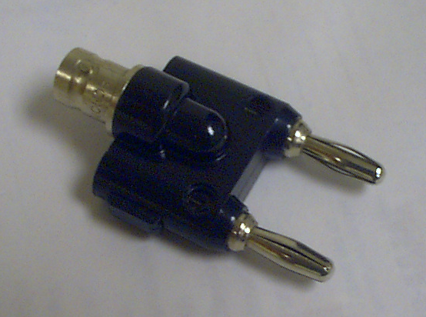
Figure 8: A Dual banana to BNC adaptor

Dual-banana plugs (plug will again refer the male gender of the connector) consist of two prongs that are inserted into the socket. One side of a dual banana plug has a little bump on it. This indicates that the prong on that side of the connector should be connected to the ground lead. Some dual-banana connectors actually have the letters ‘GND’ written on the bump to remind you what the purpose of the bump is. In a dual-banana to BNC adaptor the ground prong connects to the outer part of the BNC side of the connector; the other prong connects to the signal lead. Using these adaptors correctly (i.e. paying attention to where the ground prong plugs in) can allow a piece of equipment with a dual-banana plug to connect to one that uses BNC connectors.

You will also use what are known as BNC T’s. These devices are used to split the signal so that it can go to more than one place – for example, if you wanted to measure the voltage across the light bulb in the example with both an oscilloscope and a multimeter, then you would use a BNC Tee. When using these adaptors, you must keep track of the impedances to which the T is connected. Not doing so will produce incorrect measurements.
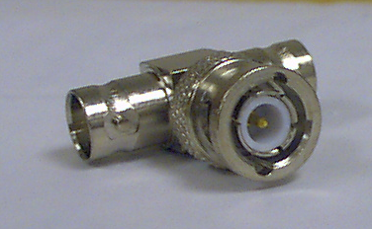
Figure 9: A BNC T

The final connector with which you will become familiar during AM 310 are clip type connectors.

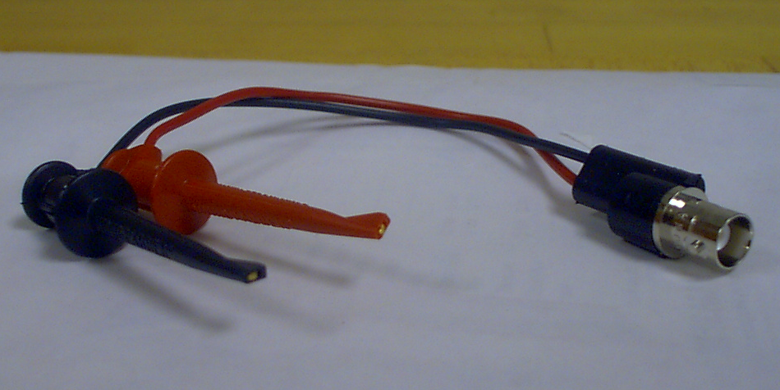

Figure 10: BNC to clip adaptor

A common type of clip connector, with which you may be familiar, is an alligator clip connector; however this is not the type that you will use in AM 310. Instead you will use connectors with a spring loaded hook (Figure 10) which provide not only good mechanical and electrical connection, but also minimize the amount of exposed conductor. This is their major advantage over alligator-type clips. Typically you will use a clip to BNC adaptor to connect circuits (which have been built on bread boards) to the oscilloscope, power supply or function generator. The red clip is connected to the center pin of the BNC connector, and the black clip is connected to the outer part, the ground, of the BNC connector.

  - Oscilloscopes

The oscilloscopes on the carts were manufactured by Good Will Instrument Co., Ltd., located in Hsin-Tien city, Taiwan. Their web site is located at www.goodwill.com.tw.

As mentioned previously, the oscilloscopes are analog oscilloscopes. They have two input channels, as well as an input for a trigger signal. There are a variety of trigger options, included one (called ‘alternate triggering’) that facilitates the stable display of the signals input on channels one and two, even if they are of different frequency. Connections to the oscilloscope (for the two signal channels and the external trigger input) are made via BNC sockets. The input connectors are found on the front face of the oscilloscope. There are two additional BNC connectors on the rear of the oscilloscope: one provides output of the signal input to channel 1 (with a 50 Ohm output impedance), and the other allows the intensity of the display (the brightness) to be modulated (this is called the ‘z-axis’ input). Finally, another feature of these oscilloscopes is that they come equipped with a 10:1 probe. These probes can be used to examine signals with voltage amplitudes larger than the maximum rated input voltage of the oscilloscope.

  - Multimeters

The multimeters on the carts were made by Hewlett-Packard, which has since become Agilent. Their web site is located at www.agilent.com.

In addition to having the ability to measure the quantities mentioned in Section 2.2, the multimeters you will use can measure frequency (or period), do continuity tests and test diodes.

The multimeter’s operation is controlled by the set of buttons on its front face. In usual operation, the measurement mode should be set, and then connection to the meter should be made. Connections to the meter are made via banana-plug sockets. There are sockets located on both the front and rear of the multimeter; to measure from the rear connections, the “front/rear” button must be set to “rear.” To measure from the front connectors, the button must be set to “front.” Care must be taken when connecting to the multimeter – follow the guides printed on the front face and rear.

To measure the (DC) voltage across a light bulb (as in the example introduced above) the multimeter must be connected in parallel with the bulb. To begin, the multimeter should be set to measure DC voltage by pressing the appropriate button. Next, the connection to the circuit should be made; this is best done using a clip to BNC adaptor on either side if the bulb. The red clip should be placed between the positive pole of the battery and the bulb. The black clip should be placed after the bulb, and before the negative pole of the battery. Next, a BNC cable should be attached to the clip to BNC adaptor. Now the connection to the multimeter can be made via a BNC to dual-banana plug adaptor. Since voltage is being measured, the dual-banana connector should be plugged into the two upper right sockets, labeled “HI” and “LO”, below the word “Input.” The ‘V’ under “input’ stands for voltage. The ground side of the dual-banana connector (the side with the bump on it) must plug into the “LO” socket.

To measure the (DC) current drawn by the bulb first set the multimeter to measure DC current by pressing the appropriate button. Next, connect the circuit to the multimeter which as mentioned above must be made in series. As in the voltage measurement, a BNC cable with a clip to BNC adaptor on one end BNC to dual banana adaptor on the other can be used to connect the bulb to the multimeter. Instead of placing the clips on either side of the bulb they must be placed on the same side, but without any wire from the circuit in between them. In written form, this description sounds awkward; however if you look at Figure 4, you should be able to interpret its meaning unambiguously. The ground plug on the dual banana connector should be connected to the same socket as when measuring voltage; however, the other plug should be plugged into the socket labeled “I,” for current.

  - Function Generators

The function generators on the equipment carts were made by Hewlett-Packard, which as mentioned above has since become Agilent. Their web site is located at www.agilent.com.

The signal out and trigger signal are output via two separate BNC connectors on the front panel of the function generator. Operation of the function generator is controlled by the set of buttons on the front panel. In addition to providing sine, square and triangle waves at its output, these function generators can output pulses with varying duty cycles and also user-defined arbitrary waveforms. The user can input the arbitrary wave form using the general-purpose interface bus (GPIB), and software provided by Agilent.

The output impedance of the function generators is 50Ω. As discussed in Section 2.3, the display of this function generator will only read the same voltage that as delivered to a component to which it is connected if that component has an input impedance of 50Ω. This is not to say that the function generator cannot be used to drive component with input impedance other that 50Ω. It simply means that you must independently monitor the voltage input to the component. As an example, if you connect the function generator to the oscilloscope directly (the oscilloscope has an input impedance of 1 MΩ) you would measure a different peak to peak voltage than what was displayed by the function generator, in fact the value from the oscilloscope should be about two times that shown on the function generator.

  - Power Supplies

The power supplies on the cart were made by Hewlet-Packard, which (again) has since become Agilent. Their web site is located at www.agilent.com.

Connection to the power supply is made through dual banana connectors. This power supply provides 0-6V on one set of banana sockets, and +/- 25 volts on another. Both of them can be referenced to chassis ground by connecting to the green-colored banana socket. The operation is controlled via the set of buttons on the front panel of the power supply. These power supplies are equipped with current limiting circuitry to protect against some forms of potentially damaging incorrect use.

- Experimental Procedure

  - Using the Oscilloscope

    - Frequency Measurement

The first part of the experiment involves viewing the various waveforms generated by the function generator. Hook up the output of the function generator to the oscilloscope channel one input. Connect the function generator sync to the external trigger of the oscilloscope. Set the wave form in the function generator to sine, the frequency to 100kHz and the amplitude to 1 Vpp, (as displayed on the function generator). Now adjust the scope to view the signal in an appropriate scale.

SPOT CHECK: Using the settings in the time/dev dial in the scope, verify that the frequency in the scope matches the output frequency of the function generator.

Repeat the same procedure and spot check for square and triangular wave forms at 100 kHz with the same amplitude.

    - Voltage Measurement

The second part of the lab involves determining the peak-to-peak voltage of a sinusoidal waveform. Set the function generator to output a 50 kHz sine wave with amplitude 1 VPP (as displayed on the function generator display). Observe the signal on the oscilloscope and determine the rms value of the voltage by measuring the peak to peak voltage of the signal. As part of the pre-lab, you should write down the formula for the rms voltage and also the method to determine it from the peak-to-peak voltage.

    - Phase Measurement

The third part of the experiment involves measuring the phase shift between two different signals. To generate the two signals you will use an RC circuit.

Build the circuit with a 121Ω resistor and a 1 μF capacitor as shown in Figure 11. You will use this circuit in the next lab, so make sure to label it with your group number/names. As an aid to interpreting the diagram, remember that the BNC cables you are using are two cables in one: the outer sheath is ground, and the inner conductor is the signal.

Measure the amplitude and phase shift of the output signal v_{o} measured across the capacitor for the following frequencies (in Hz) 100, 200, 1000, 2k, 10k. v_{o} is the amplitude measured by channel 2 of the oscilloscope. It is called v_{o} because if the circuit was used as a low pass filter it would be the output of the filter. Ensure that the measured input voltage amplitude, v_{i}, (so named, again, because if the circuit was used as a low pass filter this would be the input voltage) is maintained at 10 volts peak-to-peak. v_{i}, is the amplitude measured by channel one of the oscilloscope. The phase shift is computed from the measured values A and B, (defined as in Figure 12) by Equation 2:

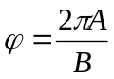 (2)

Oscilloscope
G
G
G
C2
C1
TR
Function Generator
SIG
TR
G
G
R
C
v_{i}
v_{o}

Figure 11: Wiring diagram for RC circuit. In the diagram ‘G’ stands for ground. On the function
generator, ‘SIG’ stands for signal out, and ‘TR’ stands for trigger signal out. On the oscilloscope, ‘C1’ refers to channel 1, ‘C2’ to channel 2, and ‘TR’ to trigger in. The dashed lines indicate the center conductor of the BNC cable, while the solid line indicates the outer sheath. The gray t-shaped box indicates a BNC T.

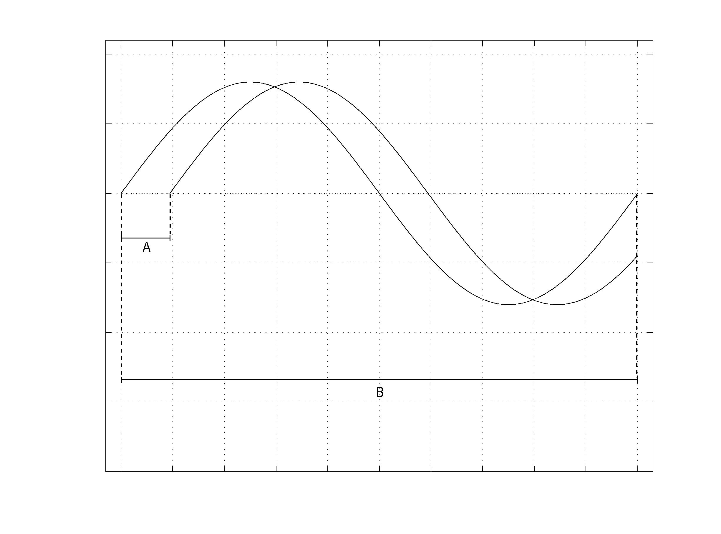
Figure 12: To compute the phase shift in radians use Equation 2, with A and B defined as in the figure.

    - Capacitance Measurement

Measure the capacitance of the capacitor from your RC circuit. You will not need to change any wiring in your circuit; however you will have to use a different resistor – the TF will provide you with one. You can find the capacitance of your capacitor using Equation 3, which gives the voltage across a capacitor (v_{c}) in an RC circuit in response to a step change in input voltage, as a function of time.

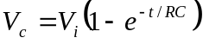 (3)

v_{i} is the amplitude of the step change in voltage input to the circuit (channel 1 of the oscilloscope), R is the resistance of the resistor, C is the capacitance of the capacitor, and t is the time after the step change in voltage. Using the oscilloscope, you can measure t, v_{c}, and v_{i}, and using the multimeter you can measure R (you will be instructed to do this in the next section). Since C is the only unknown, you can solve the equation for it.

After switching the resistors, set the function generator to output a square wave with frequency near 20 Hz and amplitude 10 Vpp (the maximum of the function generator). The square wave will simulate the step change in voltage. Adjusting the settings on the oscilloscope in an appropriate way (you will have to figure out the correct way), you should be able to display the input signal and the voltage across the capacitor in a manner similar to Figure 13.

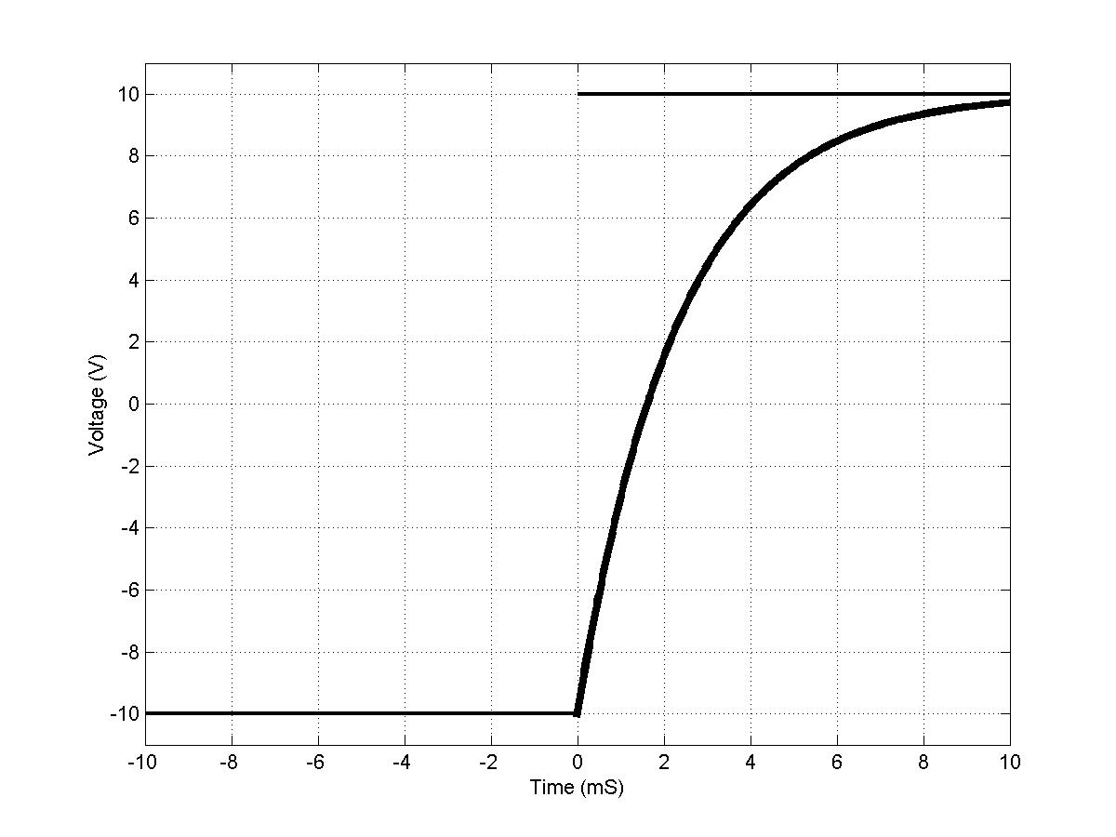
Figure 13: Sample oscilloscope trace for capacitance measurement

Measure a t,v_{c} pair.

SPOT CHECK: Use Equation 3 to see if your measurements are close to the rated value of the capacitor (1 μF).

Once you are confident of your measurement technique, measure 4 more pairs of t and vc. You should calculate the average from these 5 measurements to find the value of the capacitance of the capacitor. You will need this value for the next lab, (again, make sure to label your circuit).

  - Using the Multimeter

In this section of the experiment, the multimeter will be used to measure resistance, and voltage (AC and DC). You will measure the voltage across a resistor (whose resistance you will also measure) and the current drawn by that resistor. If done correctly the measured values should obey Ohms law.

    - Measuring Resistance

Connect a multimeter to a decade resistance box provided and change the resistance. Measure the resistance using the multimeter. Determine the error between the value shown by the decade box and the multimeter by selecting different combinations of rows and columns of values. Repeat this procedure until you feel you have a good estimate of the error for most rows and columns on the box.

Measure the resistance of the resistor given to you as part of the RC-circuit (record this measurement because you have to use it for the next lab) and the one you used to measure the capacitance of the capacitor.

    - Measuring Current and Voltage

Part 1: For a single frequency, measure the voltage across the resistor (the one from the capacitance measurement) and the current drawn by it for 5 different voltage amplitudes on the function generator.

SPOT CHECK: Check to see that your measurements satisfy Ohm’s law.

Function Generator
G
G
TR
SIG
Multimeter: AC I
I
LO
Multimeter: AC V
LO
R
V
Figure 14: Current and Voltage measurement wiring diagram

Part 2: Replace the function generator with the DC power supply. Measure the voltage and current for DC voltages of .1, .2 and .3 V (i.e. the voltage level out of the power supply).

- Results and Discussion

1. What are the percentage errors (i.e. for the sine, triangle and square wave) of the measured frequency in Section 4.1.1. relative to the indicated frequency?

2. Plot the amplitude ratio of the low pass filter as a function of frequency

3. Plot the phase difference as a function of frequency (on a separate set of axes than the axes in part 2.)

4. What is the average of your 5 measurements of capacitance from Section 4.1.4?

- Authors

Written by Mr. M. Kanagavel (Jan. 1999)
Revised by Dr. R.G. Holt (Jan. 1999)
Revised by Mr. P. Edson and Dr. R.G. Holt (Jan. 2000, Aug. 2001)
Revised by Mr. C. Thomas and Dr. R.G. Holt (May 2003)

